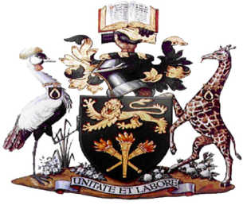

**UNIVERSITY OF NAIROBI**

**SCHOOL OF EDUCATION**

**DEPARTMENT OF PHYSICAL EDUCATION & SPORT**

**____________________________________________________________________________________________________**

**Draft**

**Subject: Semester Two 2020/2021 Academic Year**

**Online Examination Dates 3rd May to 14th May 2021**

|  |  |  |  |  |  |
| --- | --- | --- | --- | --- | --- |
| **UNIT** | **TITLE** | | **DATE** | **TIME** | **LECTURER IN CHARGE** |
| TPE 621 | Gender and Sport | | Monday 3rd May 2021 | 6PM-9.00PM | Dr. Janet Wanjira |
| TPE 609 | Fitness Testing and Evaluation | | Wednesday 5th May 2021 | 6PM-9.00PM | Dr. Nicolas Bailasha |
| TPE 624 | Doping in Sport | | Friday 7th May 2021 | 6PM-9.00PM | Dr. Janet Wanjira |
| TPE 614 | Coach Education and Sport Development | | Tuesday 11th May 2021 | 6PM-9.00PM | Dr. Michael Otieno |
| TPE 610 | | Sociology of Sport | Thursday13th May 2021 | 6PM-9.00PM | Dr. Janet Chumba |



Dr. Simon Munayi

**Chairman, PE & Sport**

Cc Dean, School of Education

8th April 2021